Manual for onsite direct access/connection to the ZTE MSS/MGW during emergency cases

Content

1. Brief description of onsite direct access to ZTE MSS/MGW during emergency case
2. List of regions where ZTE MSS/MGW are being used
3. List of MAC addresses who has privilege to direct connection
4. Location of Network elements on site
5. Setting up IP addresses and routes
6. Share connection with remote user
7. Brief description of onsite direct access to ZTE MSS/MGW during emergency case

In this manual emergency case means when remote user/client connected to ZTE MSS/MGW and some problem might happen with the connection between remote user and ZTE MSS/MGW, and O&M link might be lost. In this situation, user cannot do any operation on NE (Network elements, in our case, it is MSS, MGW). In such critical situation, we need to involve local engineer of that particular region in order to help to get access to ZTE MSS/MGW.



1. List of regions where ZTE MSS/MGW are being used

In below table there are list of regions where ZTE MSS/MGWs are located. And also information about ports are provided. Those ports are located on routers and local engineer will use it to connect to one’s computer in order to get access to ZTE MSS/MGW.

|  |  |
| --- | --- |
| Region | Router (CISCO) Port |
| Urgench | SW2 Gi1/16 |
| Navoi | SW2 Gi3/15 |
| Nukus | SW2 Gi1/30 |
| Karshi | SW2 Gi1/10 |
| Termez | SW2 Gi3/15 |
| Buhara | SW1 Gi2/3 |
| Djizzakh | SW1 Gi1/14 |
| Samarkand | SW2 Gi3/15 |
| Denau | SW1 Gi1/0/21 |
| Shahrisabz | SW1 Gi0/21 |
| Zarafshan | SW1 Gi1/0/35 |
| Kokand | SW1 Gi1/35 |
| Gulistan | SW1 Gi1/35 |
| Andijan | SW1 Gi1/30 |
| Fergana | SW1 Gi3/35 |
| Namangan | SW1 Gi1/35 |
| Tashkent | SW1 Gi1/35 |
| Almalik | SW1 Gi7/28 |

In every regions core site there are two Router, and SW1 and SW2 and each has its own ports. So in case of emergency, local engineer of that particular region should enter core site and find SW1 or SW2 according to above table and connect one’s computer:

 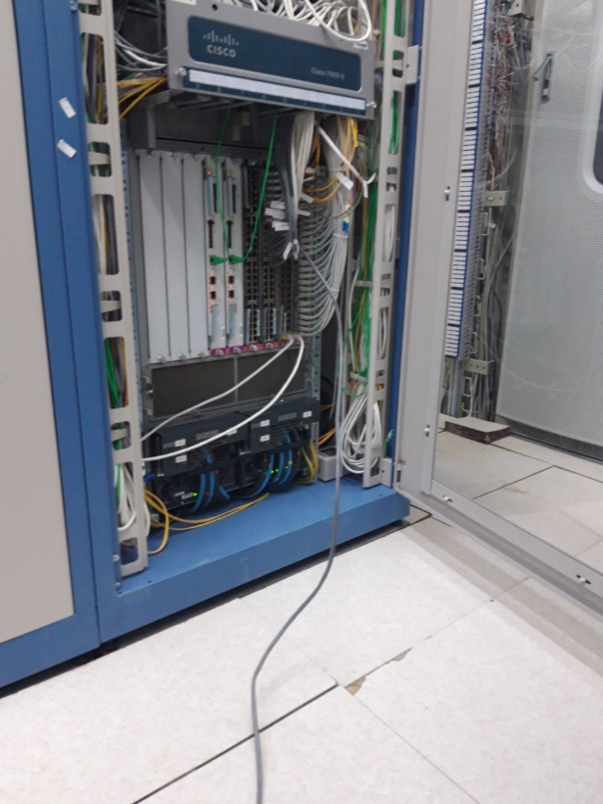 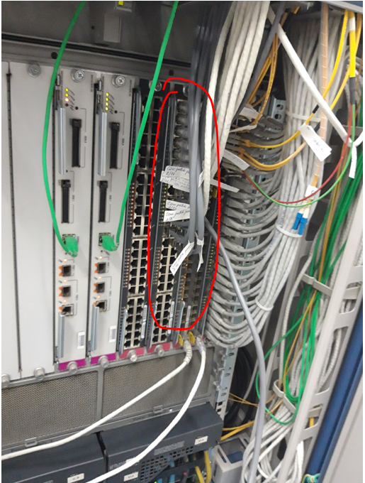

1. List of MAC addresses who has privilege to direct connection

Below table shows list of local engineer with MAC addresses of their computers

|  |  |  |  |
| --- | --- | --- | --- |
| Region | Comp name | MAC address | Owner |
| Bukhara | UCELL0029-KA | EC-8E-B5-A2-F4-8C | Mirza Avagimyanst |
| Bukhara | UCELL0025-KA | 34-64-A9-06-4C-13 | Firdavs Imamov |
| Djizak | UCELL0012-DA | EC-8E-B5-A2-07-0C | Murad Kurbanov |
| Djizak | UCELL0033-DA | EC-8E-B5-A4-0E-37 | Laziz Shodmonov |
| Nukus | UCELL0007-NA | FC-3F-DB-8E-51-18 | Muratbay Seidov |
| Nukus | UCELL0030-NA | EC-8E-B5-A2-B6-9E | Salavat Kudaybergenov |
| Karshi | UCELL0040-IA | 70-5A-0F-CF-04-3A | Kamoliddin Javliev |
| Khorezm | UCELL0019-MA | 98-E7-F4-33-1B-77 | Yakhshimurod Ruzmetov |
| Khorezm | Ucell0022-MA | EC-8E-B5-A2-F6-77 | Birodar Madaminov |
| Navoi | UCELL0060-LA | 40-B0-34-F0-08-C3 | Tulkin Urazov |
| Navoi | UCELL0033-LA | EC-8E-B5-A2-07-21 | Elyor Usmonov |
| Samarkand | UCELL0068-EA | EC-8E-B5-A4-0E-AE | Sherzod Sulaymanov |
| Termez | UCELL0066-JA | EC-8E-B5-A2-D6-3D | Makhmud Baymuratov |
| Termez | UCELL0043-JA | EC-8E-B5-A2-17-AE | Orzubek Kadirov |
| Denau | UCELL0044-JA | EC-8E-B5-A2-F6-CF | Yokub Normamatov |
| Denau | UCELL0042-JA | EC-8E-B5-A4-8D-58 | Zokir Aralov |
| Shakhrisabz | UCELL0044-IA | EC-8E-B5-A5-76-7F | Avulov Faxriddin |

In case of emergency, these local engineers have to go to core site and connect their computers with appropriate MAC addresses and connect to assigned ports on the router (CISCO). The list of MAC addresses and engineers need to be updated every 6 month by testing connection with every region’s local engineers.

1. Location of Network elements on site

In order to reduce time to get connection and facilitate local engineers to go to find out requied NE below schemes of ZTE MSS/MGW and routers for each region might be informative:















1. Setting up IP addresses and routes

After physical connection between local engineer’s computer and CISCO router, local engineer has to configure all required IP addresses and static routes on computer. In order to set up IP addresses run below BAT files for your region:

|  |  |
| --- | --- |
| Region | BAT file |
| Samarkand |  |
| Djizakh |  |
| Bukhara |  |
| Navoi |  |
| Karshi |  |
| Shakhrisabz |  |
| Termez |  |
| Denau |  |
| Nukus |  |
| Urgench |  |

BAT file can be run directly here or can be copied to local disk or desktop and run there. Sometimes automatic running BAT file may not set up IP addresses properly and still connection cannot be granted. In such case, just copy BAT file in your local disk or desktop and open by click right button of mouse and go to Edit:

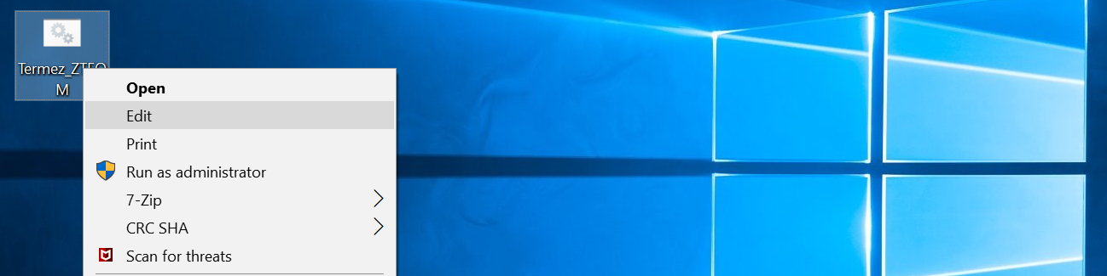

And you will get in to inside BAT file and see all relevant configurations for setting up:

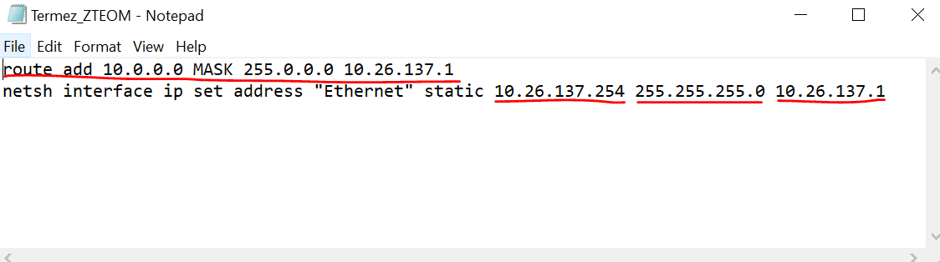

Go to Command Line by entering Window+R and write cmd

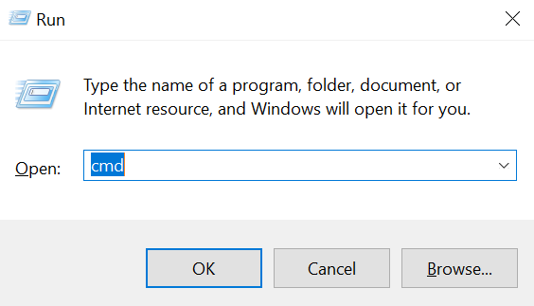

Write first line in BAT file and run

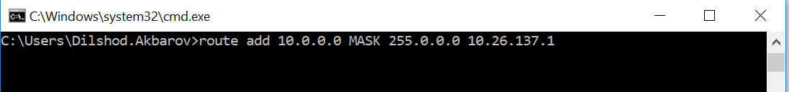

Then second line and run



If there is privilege to do that try this:

Go to Start ->Settings ->Networks & Internet ->Ethernet or Change adapter options

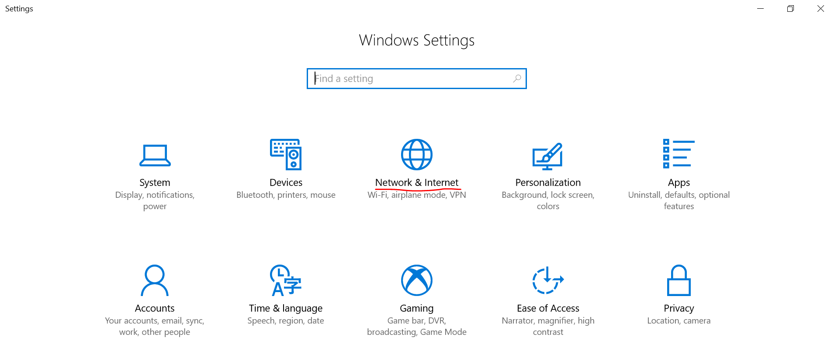

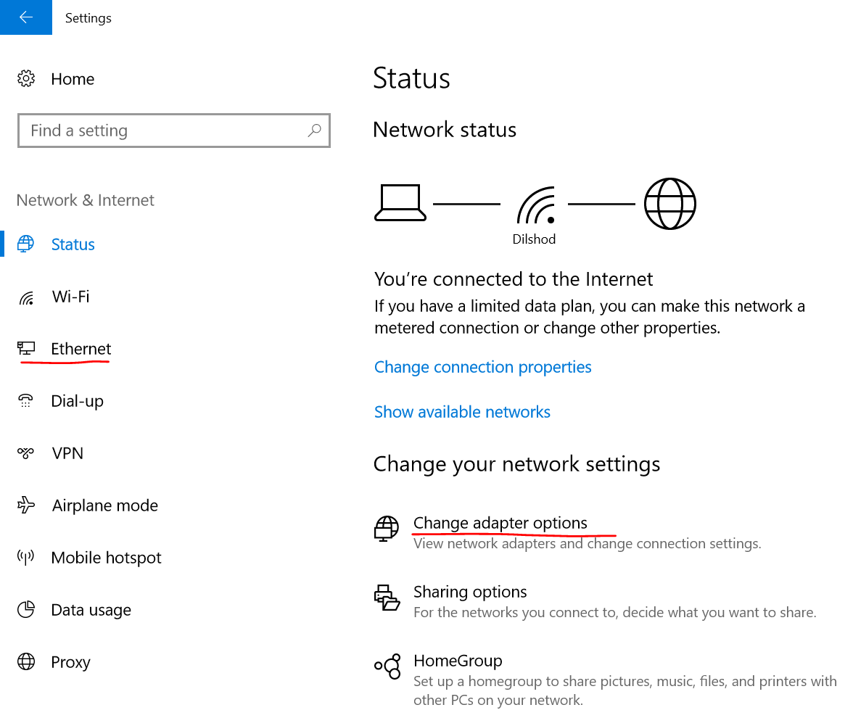

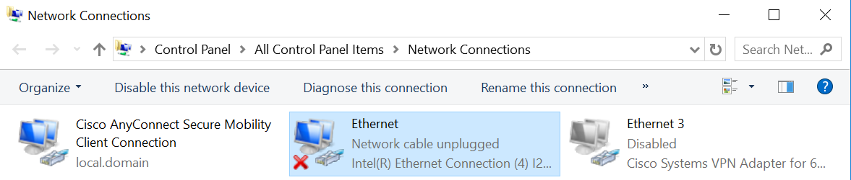

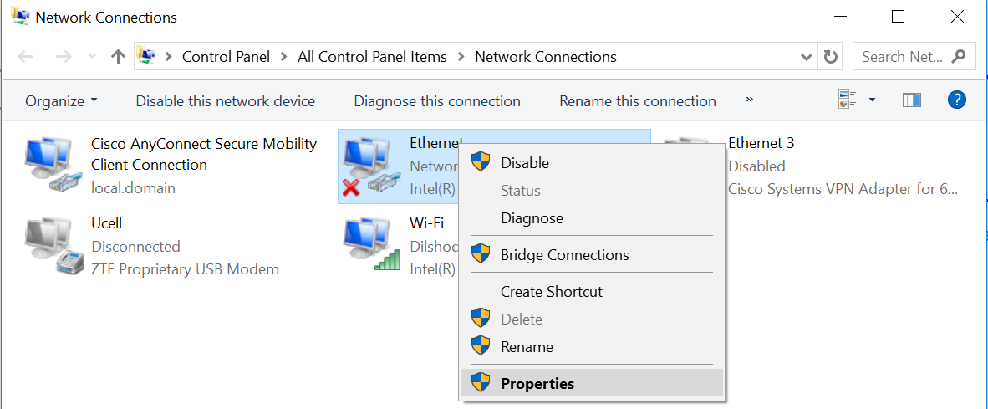

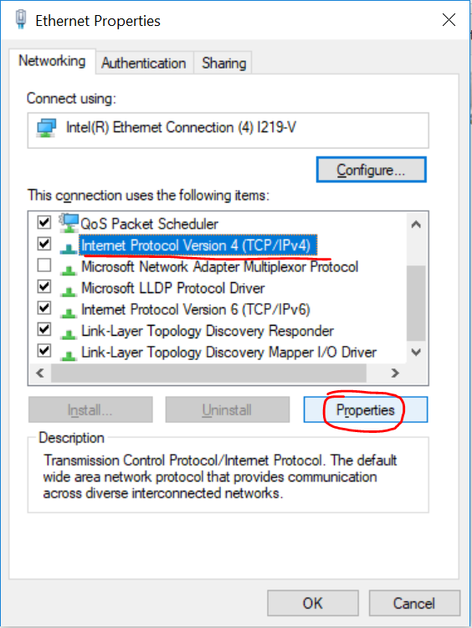

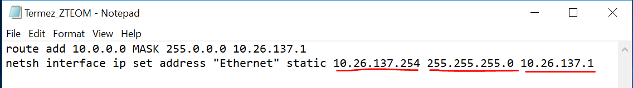

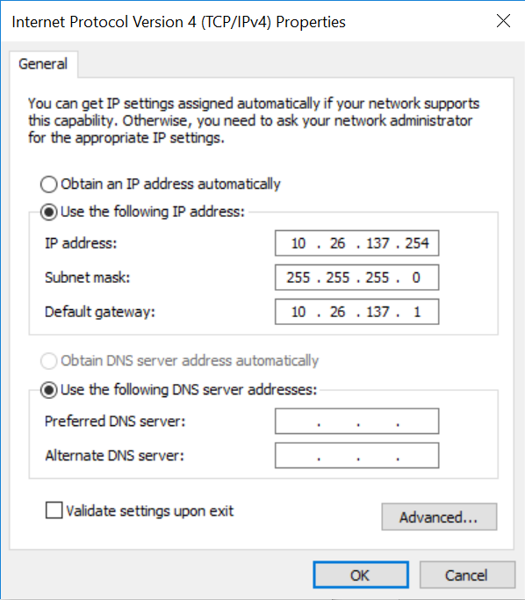

1. Share connection with remote user

After local engineer connects ZTE MSS/MGW the connection can be shared through Lync (Skype for Business 2016) sharing own desktop and giving control:

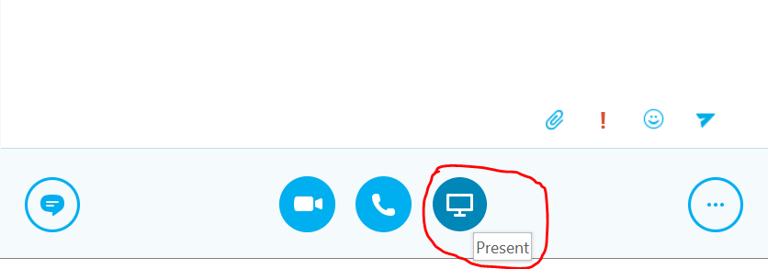

If internet speed is so slow and face difficulties with sharing desktop, remote engineer can instruct local engineer by phone or other communication tools. Also local engineer has to keep the addresses of ZTE MSS/MGWs:

|  |  |
| --- | --- |
| MSS/MGW | O&M address |
| Samarkand MSS | [http://10.26.130.55:2323/gsm_ls_17/client/#](http://10.26.130.55:2323/gsm_ls_17/client/) |
| Samarkand MGW | [http://10.26.130.62:2323/ngmgw_w_37/client/#](http://10.26.130.62:2323/ngmgw_w_37/client/) |
| Bukhara MSS | [http://10.26.129.40:2323/gsm_ls_15/client/#](http://10.26.129.40:2323/gsm_ls_15/client/) |
| Bukhara MGW | [http://10.26.129.47:2323/ngmgw_w_35/client/#](http://10.26.129.47:2323/ngmgw_w_35/client/) |
| Karshi MSS | [http://10.26.136.43:2323/gsm_ls_13/client/#](http://10.26.136.43:2323/gsm_ls_13/client/) |
| Karshi MGW | [http://10.26.136.50:2323/ngmgw_w_33/client/#](http://10.26.136.50:2323/ngmgw_w_33/client/) |
| Shakhrisabz MGW | [http://10.26.145.18:2323/ngmgw_w_40/client/#](http://10.26.145.18:2323/ngmgw_w_40/client/) |
| Termez MSS | [http://10.26.137.29:2323/gsm_ls_12/client/#](http://10.26.137.29:2323/gsm_ls_12/client/) |
| Termez MGW | [http://10.26.137.36:2323/ngmgw_w_32/client/#](http://10.26.137.36:2323/ngmgw_w_32/client/) |
| Denau MGW | [http://10.26.146.18:2323/ngmgw_w_39/client/#](http://10.26.146.18:2323/ngmgw_w_39/client/) |
| Navoi MSS | [http://10.26.135.33:2323/gsm_ls_16/client/#](http://10.26.135.33:2323/gsm_ls_16/client/) |
| Navoi MGW | [http://10.26.135.40:2323/ngmgw_w_36/client/#](http://10.26.135.40:2323/ngmgw_w_36/client/) |
| Nukus MSS | [http://10.26.128.30:2323/gsm_ls_14/client/#](http://10.26.128.30:2323/gsm_ls_14/client/) |
| Nukus MGW | [http://10.26.128.37:2323/ngmgw_w_34/client/#](http://10.26.128.37:2323/ngmgw_w_34/client/) |
| Urgench MSS | [http://10.26.140.27:2323/gsm_ls_11/client/#](http://10.26.140.27:2323/gsm_ls_11/client/) |
| Urgench MGW | [http://10.26.140.35:2323/ngmgw_w_31/client/#](http://10.26.140.35:2323/ngmgw_w_31/client/) |

Just click to O&M address and particular MSS or MGW will be open on default browser. User name and password will be provided by remote engineer.

